WASHINGTON COUNTY ELECTION BOARD
401 S. Johnstone Ave., Suite 4, Bartlesville, OK 74003 918-337-2850
Yvonne House, Secretary

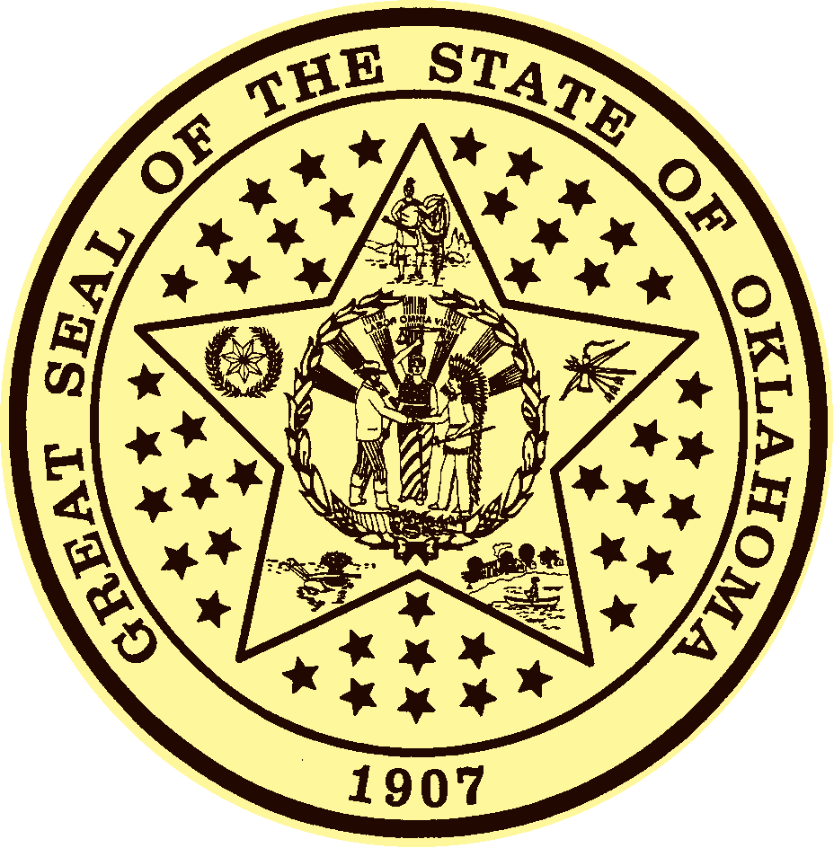
AMENDED AGENDA FOR WASHINGTON COUNTY ELECTION BOARD MEETING

As required by Title 25, Section 311, of the Oklahoma Statutes, notice is hereby given that the Washington County Election Board will hold a Meeting, , 9, , at 6:00 , Location of the meeting will be in the Election Board Office, Bartlesville City Hall Administration Building, 401 S. Johnstone Ave., Suite 4, Bartlesville OK

AGENDA

Following is a list of the business to be conducted by the County Election Board at the above-mentioned meeting:

- Elect Chairperson of the County Election Board

- Elect Vice Chairperson of the County Election Board.

- Discuss and approve minutes for the Meeting held 7, .

- Process mail, faxed and nursing home absentee ballots, including opening the outer envelopes and examining the affidavits for sufficiency, removing the affidavit envelope, opening the secrecy envelope, and counting the ballots submitted for the 9, , Special Election for the City of Bartlesville.

- Canvass all absentee and precinct results for the 9, , Special Election for the City of Bartlesville.

- Adjourn meeting.

Person Filing This Notice: Andrea Conner

____________________________________________
Yvonne House, Secretary

Posted on (date) ______________________, at ________ am/pm at the following location:

Washington County Election Board Office

